Name: Truong Dang Truc Lam  
ID: B2111933   
Class: CT209H-M04

# LAB 7: VPN AND DIRECTACCESS

## EXERCISE 1: BUILD THE NETWORK USING VMWARE WORKSTATION

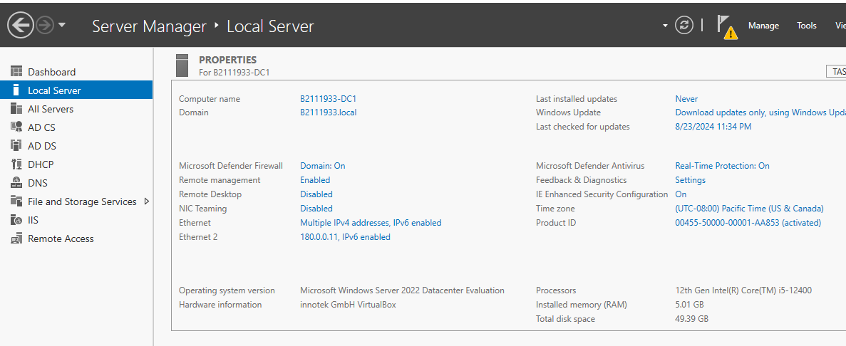

I will use DC1 as the RA server because my PC can only run 2 VMs at a time

## EXERCISE 2: INSTALL AND CONFIGURE VPN SERVER

Step 1: Installing Remote Access role

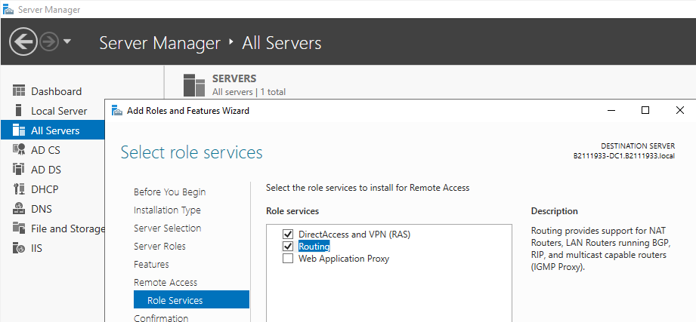

Install VPN with Routing

Step 2: Configure and Enable Routing and Remote Access on Server 2016

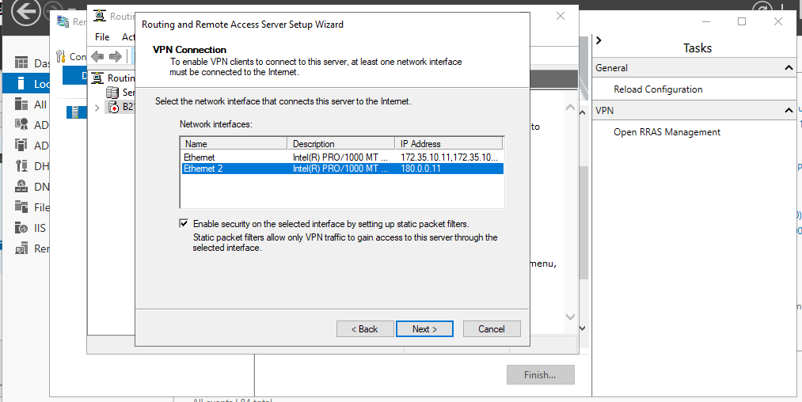

Select Ethernet 2 for VPN

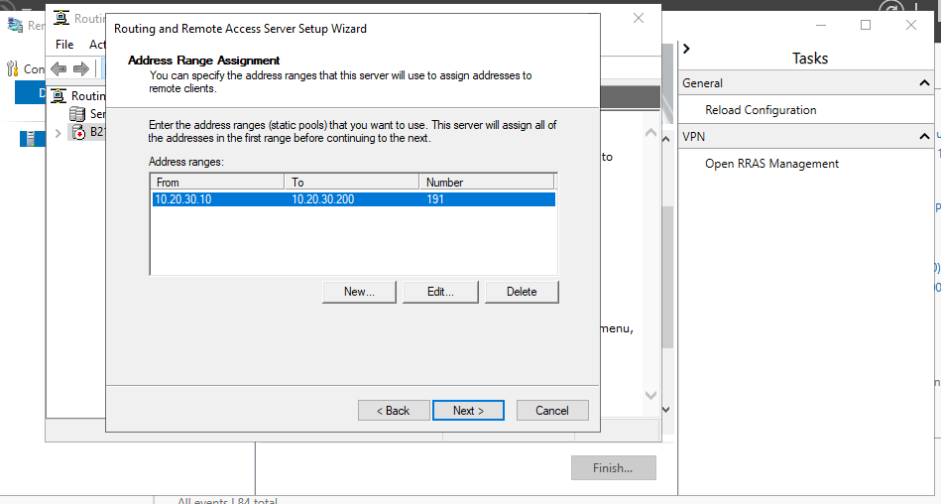

VPN IP range

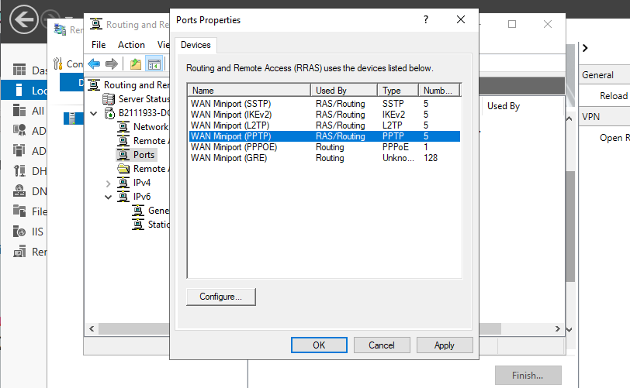

Verify that 128 ports exist for SSTP, IKEv2, PPTP, and L2TP

Step 3: Configure VPN Server Settings (Security, IP Range, etc.)

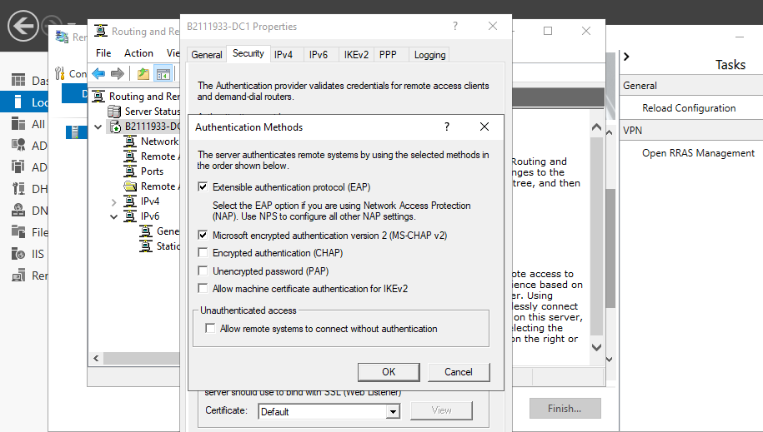

Select MS-CHAP v2 in Authentication Methods

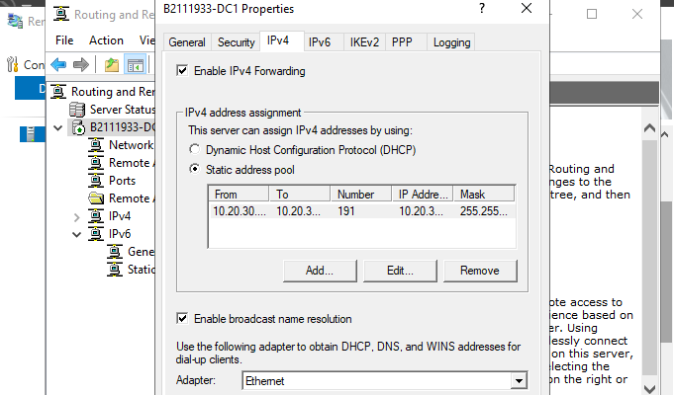

VPN Ipv4 range

Step 4: Allow Routing and Remote Access Inbound Traffic in Windows Firewall

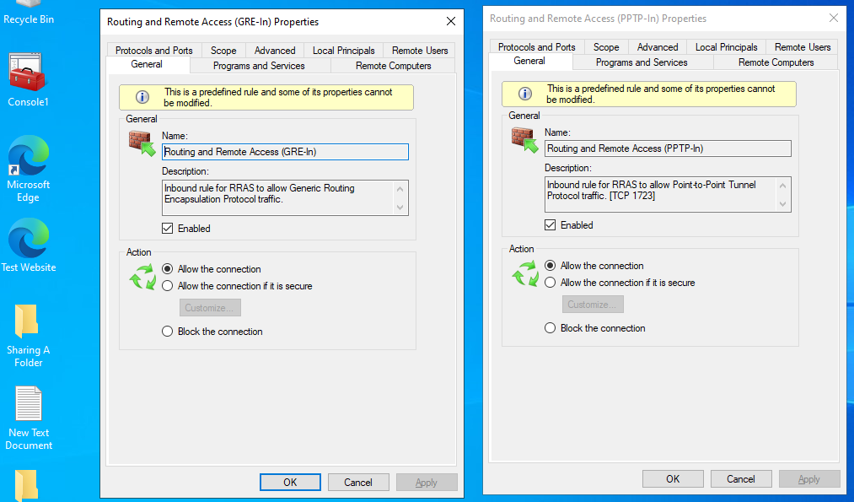

Config Inbound Traffic for Firewall to allow PPTP and GRE

Step 5: Select which users will have VPN Access

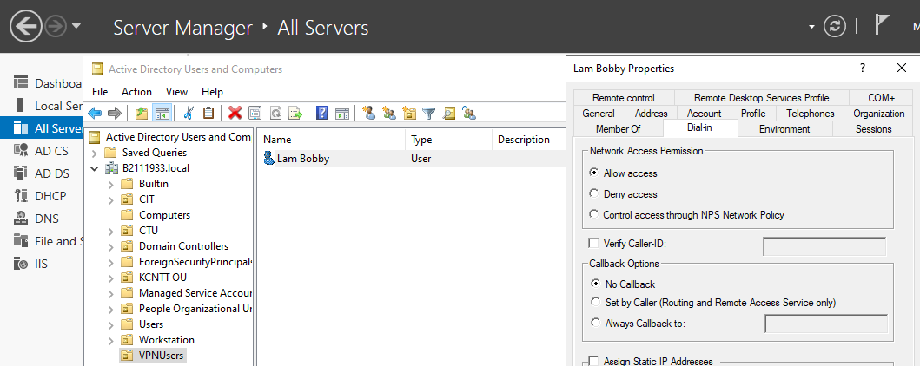

Creating OU & Users for VPN

## EXERCISE 3: SETUP VPN CONNECTION FOR CLIENT

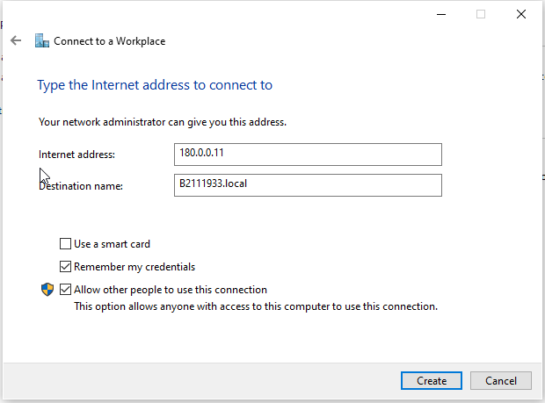

Setup VPN connection for client

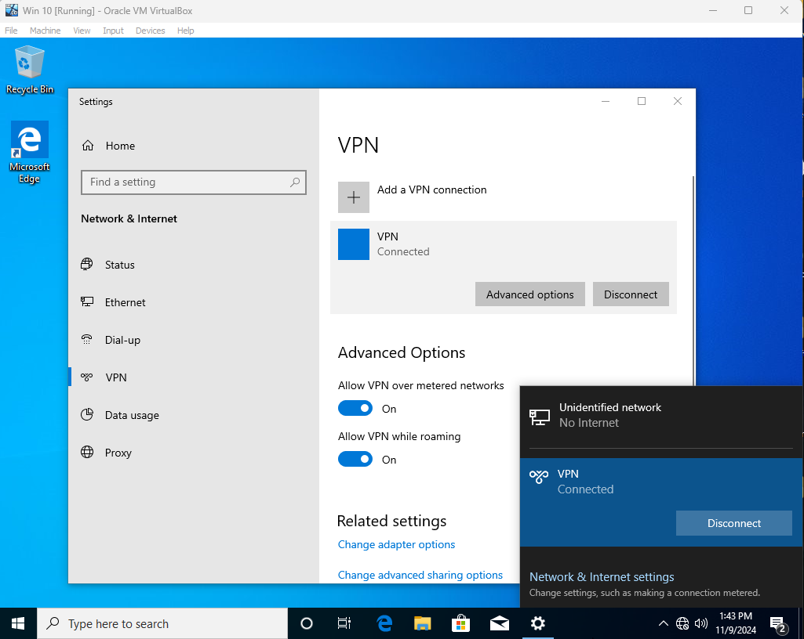

Connected to VPN

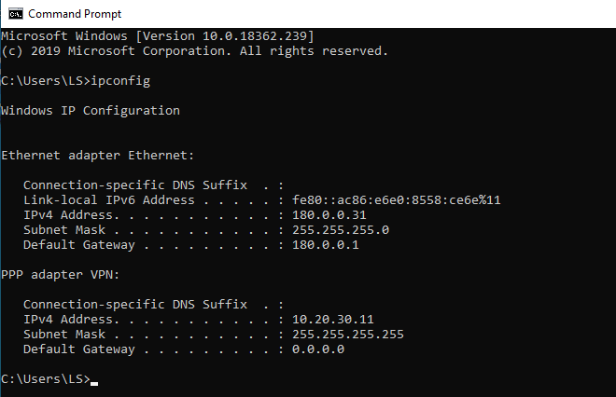

Check IP address of VPN

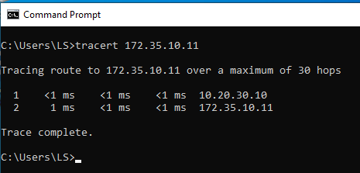

Test connectivity

It takes 2 hops to reach the destination 172.35.10.11 (the external card of the server).   
The first hop is to 10.20.30.10 (the VPN gateway).   
The VPN gateway will act as a bridge between the two networks.

**EXERCISE 4: INSTALL AND CONFIGURE DIRECTACCESS**

**A. Creating DirectAccess OU & Group in Active Directory**

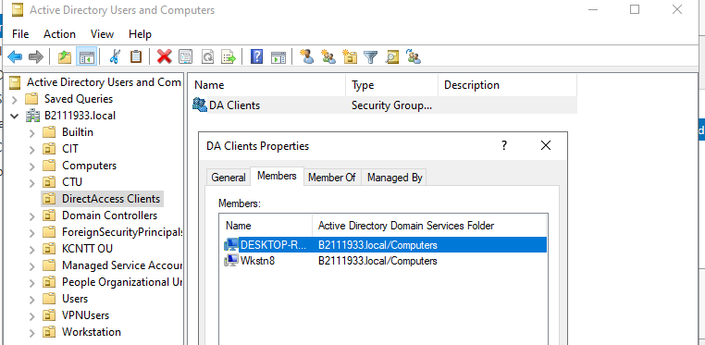

Allow those computers to use DirectAccess services

**B. Installing the Remote Access server role**

**(Already done in Exercise 2)**

**C. Configure DirectAccess**

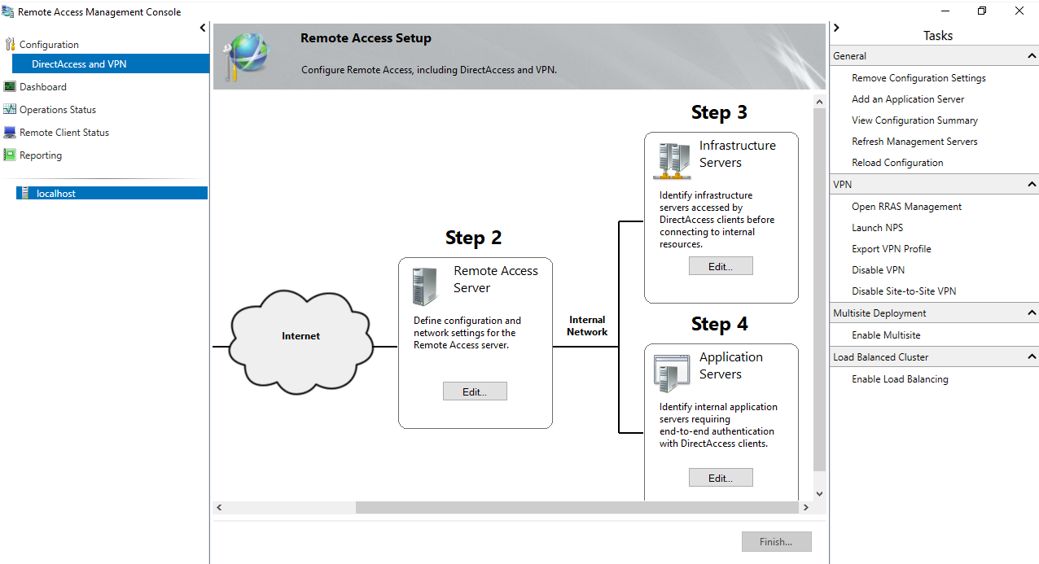

Configure DirectAccess

**D. Test Direct Access on the Windows Client**

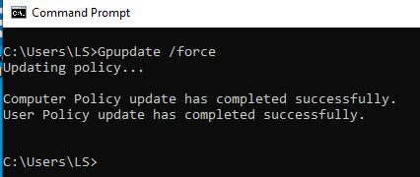

Update Group Policy on Client

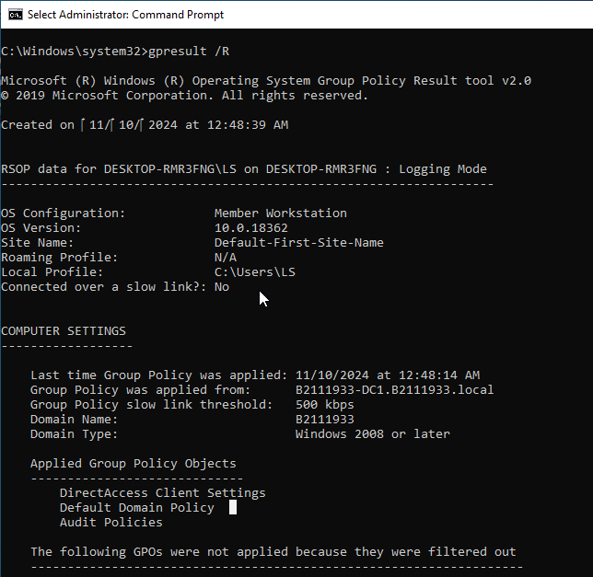

Verify that DirectAccessClient GPO applied to the client

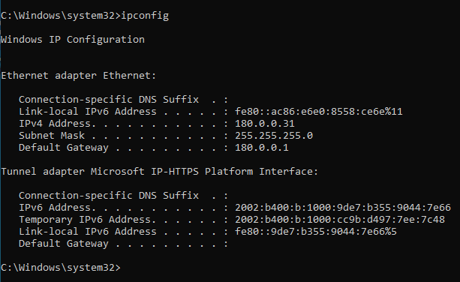

Verify connectivity to the DirectAccess server.

The IPv6 address starts with **2002:** (IP-HTTPS address)